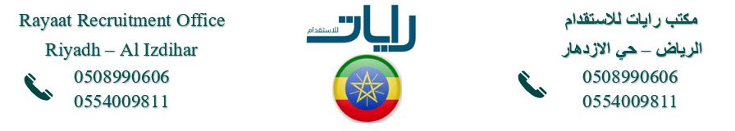
Full Body Picture
معلومات شخصية Information Personal
Nationality | {nationality} |  | اﻟﺟﻧﺳﯾﺔ
Date of Birth | {dateOfBirth} |  | ﺗﺎرﯾﺦ اﻟﻣﯾﻼد
Address | {placeOfBirth} |  | اﻟﻌﻧوان
Marital Status | {maritalStatus} |  | اﻟﺣﺎﻟﺔ اﻻﺟﺗﻣﺎﻋﯾﺔ
No. of Children | 0 |  | ﻋدد اﻷطﻔﺎل
Height/Weight | {height} | {weight} | اﻟوزن واﻟطول
Education Qualifications | HIGH SCHOOL |  | اﻟﻣﺳﺗوى اﻟﺗﻌﻠﯾﻣﻲ
Tel. Number | {phone} |  | رﻗم اﻟﺗواﺻل

خبرات سابقة Experience Overseas
Country | Period | Date
 |  | N/A

المهارات Skills
Cooking | NO | اﻟطبﺦ | Baby  Sitting |  | اﻟﺗﻌﺎﻣل ﻣع اﻷطﻔﺎل
Washing |  | اﻟغﺳﯾل | Sewing | NO | اﻟﺧﯾﺎطﺔ
Cleaning |  | اﻟﺗﻧظﯾف | Driving | NO | ﺳﺎئق

Languages |  | اﻟﻠغﺎت
اﻹﻧﺟﻠﯾزﯾﺔ English |  | Arabic | اﻟﻌربﯾﺔ
Good |  | NO | ﺟﯾد
Fluent |  | NO | ﻣﻣﺗﺎز
NO

 | Reference Number
 | Full Name | {fullName} | اﻻﺳم
 | Religion | NON-{religion} | اﻟدﯾﺎﻧﺔ
 | Position Desired | {position} | اﻟوظﯾﻔﺔ
 | Salary | {salary} | اﻟراﺗب
 | Age | 24 | اﻟﻌﻣر
 | Sex | {gender} | اﻟﺟﻧس

معلومات الجواز Information Passport
Number | {passportNumber}
Issue Date | {dateOfIssue} | اﻹﺻدار
Expiry Date | {dateOfExpiry} | اﻻﻧﺗﮭﺎء
Issue place | {nationality} | اﻹﺻدار
Next of Kin name |  | ﺧص
Next of Kin | {phone} | ﻘرﯾب
number

Remarks: SHE IS HARDWORKING, NEAT, ORGANISED, SMART, DISCIPLINED, CARING, HAS A GOOD ATTITUDE, SPEAKS GOOD ENGLISH AND LOVES TAKING CARE OF CHILDREN.

